The Capture Menu:

Menu Item | Accelerator | Description
Interfaces... | Ctrl+I | This menu item brings up a dialog box that shows what's going on at the network interfaces Wireshark knows of.
Options... | Ctrl+K | This menu item brings up the Capture Options dialog box and allows you to start capturing packets.
Start | Ctrl+E | Immediately start capturing packets with the same settings than the last time.
Stop | Ctrl+E | This menu item stops the currently running capture.
Restart | Ctrl+R | This menu item stops the currently running capture and starts again with the same options, this is just for convenience.
Capture Filters... |  | This menu item brings up a dialog box that allows you to create and edit capture filters. You can name filters, and you can save them for future use.

The Capture interfaces dialog box:

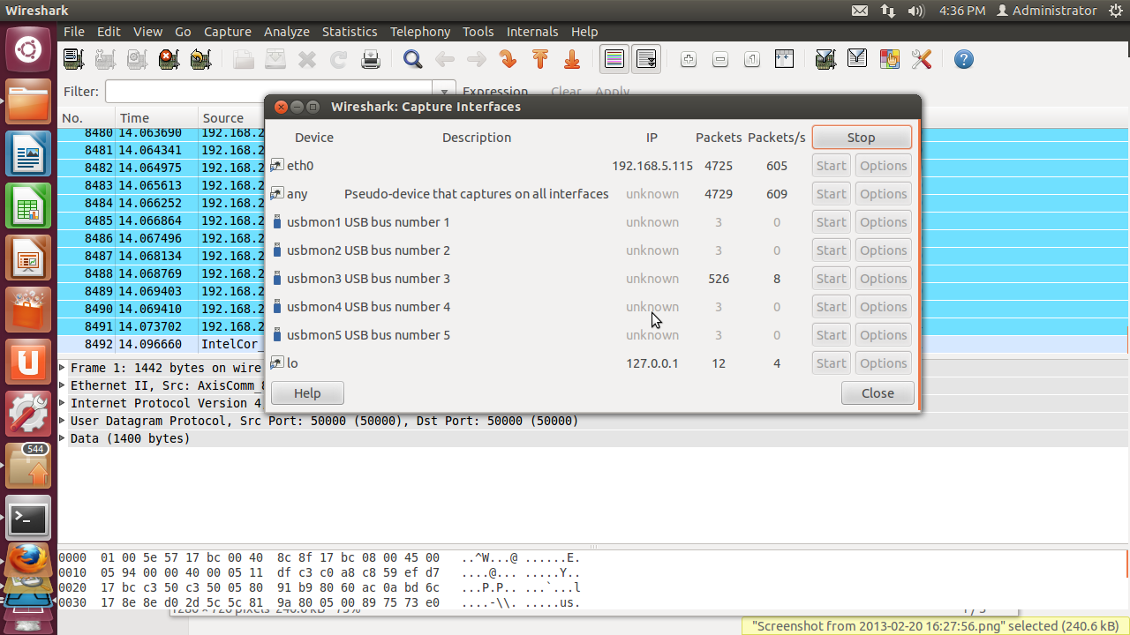

Device (Unix/Linux only)
The interface device name.

Description
The interface description provided by the operating system, or the user defined comment added in "interface options”
IP
The first IP address Wireshark could find for this interface. You can click on the address to cycle through other addresses assigned to it, if available. If no address could be found "none" will be displayed.
Packets
The number of packets captured from this interface, since this dialog was opened. Will be greyed out, if no packet was captured in the last second.
Packets/s
Number of packets captured in the last second. Will be greyed out, if no packet was captured in the last second.
Stop
Stop a currently running capture.
Help
Show this help page.
Close
Close this dialog box.

The Capture options dialog box:

Capture frame
The table shows the settings for all available interfaces:
- The name of the interface and its IP addresses. If no address could be resolved from the system, "none" will be shown.
- The link-layer header type.
- The information whether promicuous mode is enabled or disabled.
- The maximum amount of data that will be captured for each packet. The default value is set to the 65535 bytes.
- The size of the kernel buffer that is reserved to keep the captured packets.
- The information whether packets will be captured in monitor mode (Unix/Linux only).
- The chosen capture filter.
By marking the checkboxes in the first column the interfaces are selected to be captured from. By double-clicking on an interface the "Edit Interface Settings" dialog box will be opened.

Capture on all interfaces
As Wireshark can capture on multiple interfaces, it is possible to choose to capture on all available interfaces.
Capture all packets in promiscuous mode
This checkbox allows you to specify that Wireshark should put all interfaces in promiscuous mode when capturing.
Capture Filter
This field allows you to specify a capture filter for all interfaces that are currently selected. Once a filter has been entered in this field, the newly selected interfaces will inherit the filter.
It defaults to empty, or no filter.
You can also click on the button labeled "Capture Filter", and Wireshark will bring up the Capture Filters dialog box and allow you to create and/or select a filter.
Compile selected BPFs
This button allows you to compile the capture filter into BPF code and pop up a window showing you the resulting pseudo code. This can help in understanding the working of the capture filter you created. The "Compile selected BPFs" button leads you to The "Compile Results" dialog box.
Manage Interfaces
The "Manage Interfaces" button leads you to The Add New Interfaces dialog box where pipes can be defined, local interfaces scanned or hidden, or remote interfaces added (Windows only).

Capture File(s) frame
File
This field allows you to specify the file name that will be used for the capture file. This field is left blank by default. If the field is left blank, the capture data will be stored in a temporary file,
You can also click on the button to the right of this field to browse through the filesystem.
Use multiple files
Instead of using a single file, Wireshark will automatically switch to a new one, if a specific trigger condition is reached.
Use pcap-ng format
This checkbox allows you to specify that Wireshark saves the captured packets in pcap-ng format. This next generation capture file format is currently in development. If more than one interface is chosen for capturing, this checkbox is set by default.
Next file every n megabyte(s)
Multiple files only: Switch to the next file after the given number of byte(s)/kilobyte(s)/megabyte(s)/gigabyte(s) have been captured.
Next file every n minute(s)
Multiple files only: Switch to the next file after the given number of second(s)/minutes(s)/hours(s)/days(s) have elapsed.
Ring buffer with n files
Multiple files only: Form a ring buffer of the capture files, with the given number of files.

Stop capture after n file(s)
Multiple files only: Stop capturing after switching to the next file the given number of times.

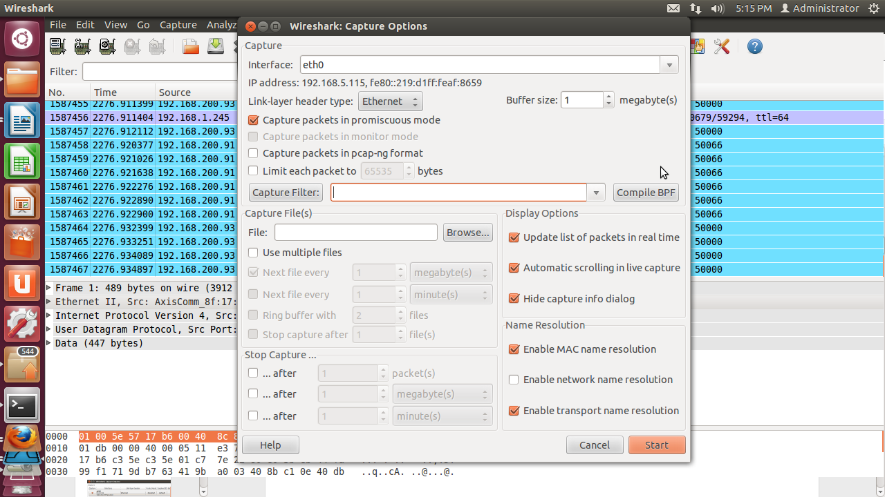

Stop Capture... frame
... after n packet(s)
Stop capturing after the given number of packets have been captured.
... after n megabytes(s)
Stop capturing after the given number of byte(s)/kilobyte(s)/megabyte(s)/gigabyte(s) have been captured. This option is greyed out, if "Use multiple files" is selected.
... after n minute(s)
Stop capturing after the given number of second(s)/minutes(s)/hours(s)/days(s) have elapsed.

Display Options frame
Update list of packets in real time
This option allows you to specify that Wireshark should update the packet list pane in real time. If you do not specify this, Wireshark does not display any packets until you stop the capture. When you check this, Wireshark captures in a separate process and feeds the captures to the display process.

Automatic scrolling in live capture
This option allows you to specify that Wireshark should scroll the packet list pane as new packets come in, so you are always looking at the last packet. If you do not specify this, Wireshark simply adds new packets onto the end of the list, but does not scroll the packet list pane. This option is greyed out if "Update list of packets in real time" is disabled.
Hide capture info dialog
If this option is checked, the capture info dialog will be hidden.

Name Resolution frame
Enable MAC name resolution
This option allows you to control whether or not Wireshark translates MAC addresses into names.
Enable network name resolution
This option allows you to control whether or not Wireshark translates network addresses into names.
Enable transport name resolution
This option allows you to control whether or not Wireshark translates transport addresses into protocols.

Buttons
Once you have set the values you desire and have selected the options you need, simply click on Start to commence the capture, or Cancel to cancel the capture.

